

**Project-1**

Course: DEVOPS

MODULE: AWS 3- Tier Architecture.

TRAINER: Mr. MADHUKAR

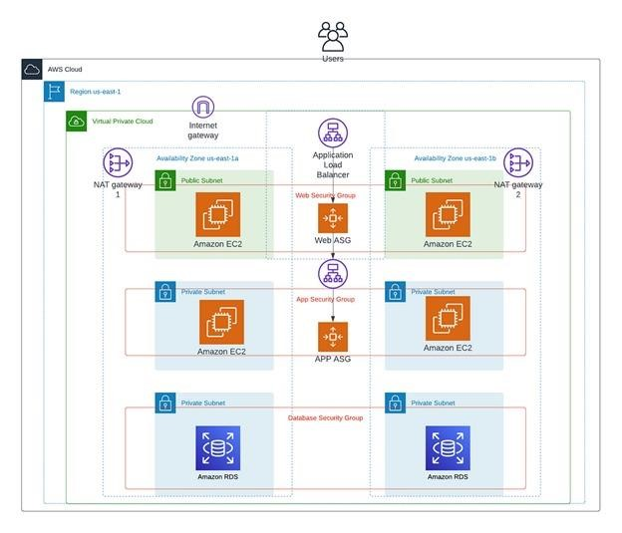

Name: KODAM GAGAN

Mobile: 9505045927

Email: kodamgagan95@gmail.com

Log in to the AWS management console.

Navigate to the VPC dashboard.

Click on “create VPC”.

Give name to your VPC.

Enter IPV4 CIDR (104.0.0.0/16) as your own Ip address.

Click on “create VPC”.

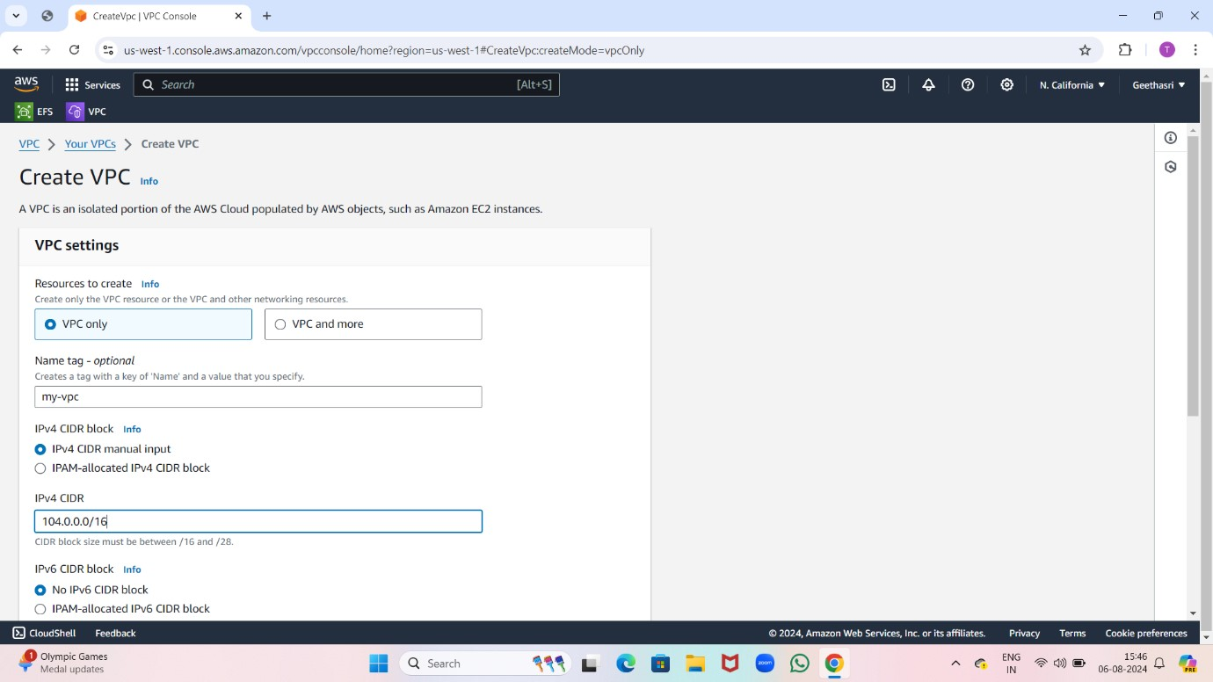

Now your own VPC created.

Now go to subnets and click on “create subnets”.

Select your own VPC and give subnet name public one.

Enter IPV4 CIDR block and select availability zone.

Then click on “create subnet”.

Now create two another two public subnets with different availability zone and create three private subnets with different availability zone.

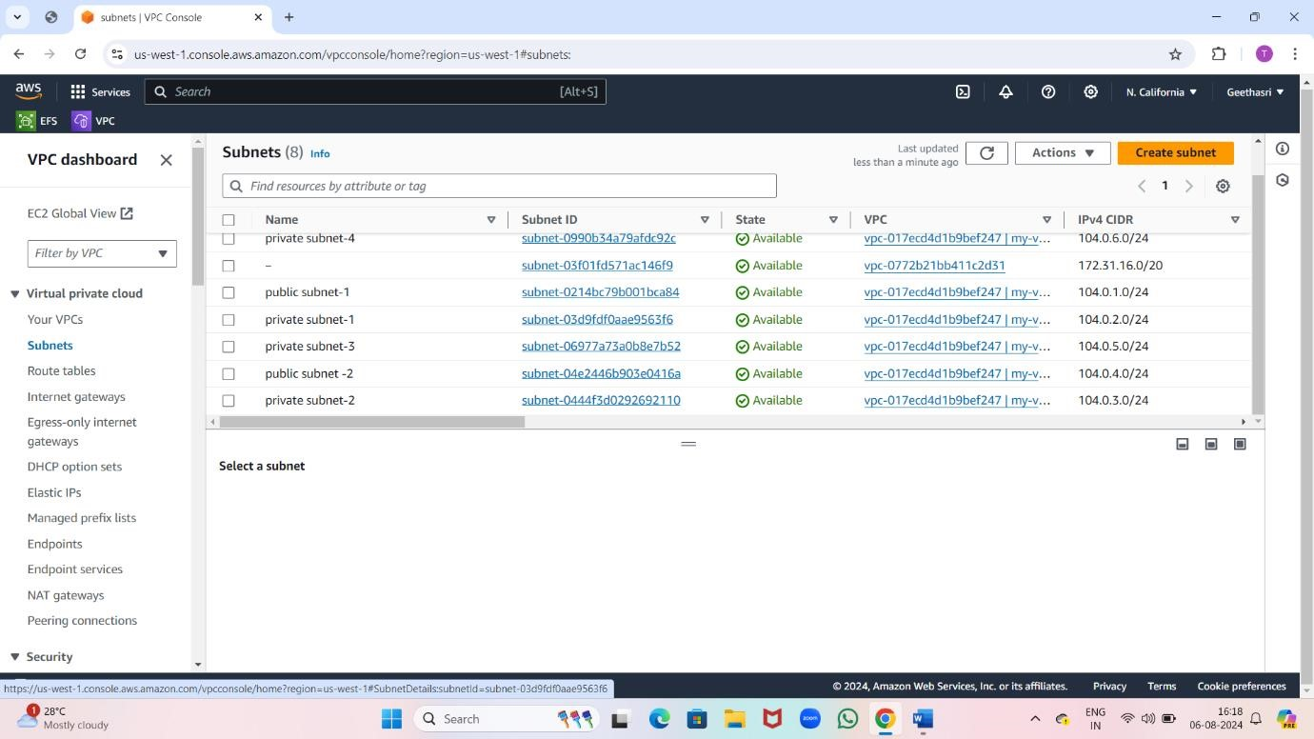

Now create an INTERNET GATEWAY (IGW).

Click on “create internet gateway”.

Attach the internet gateway to you VPC.

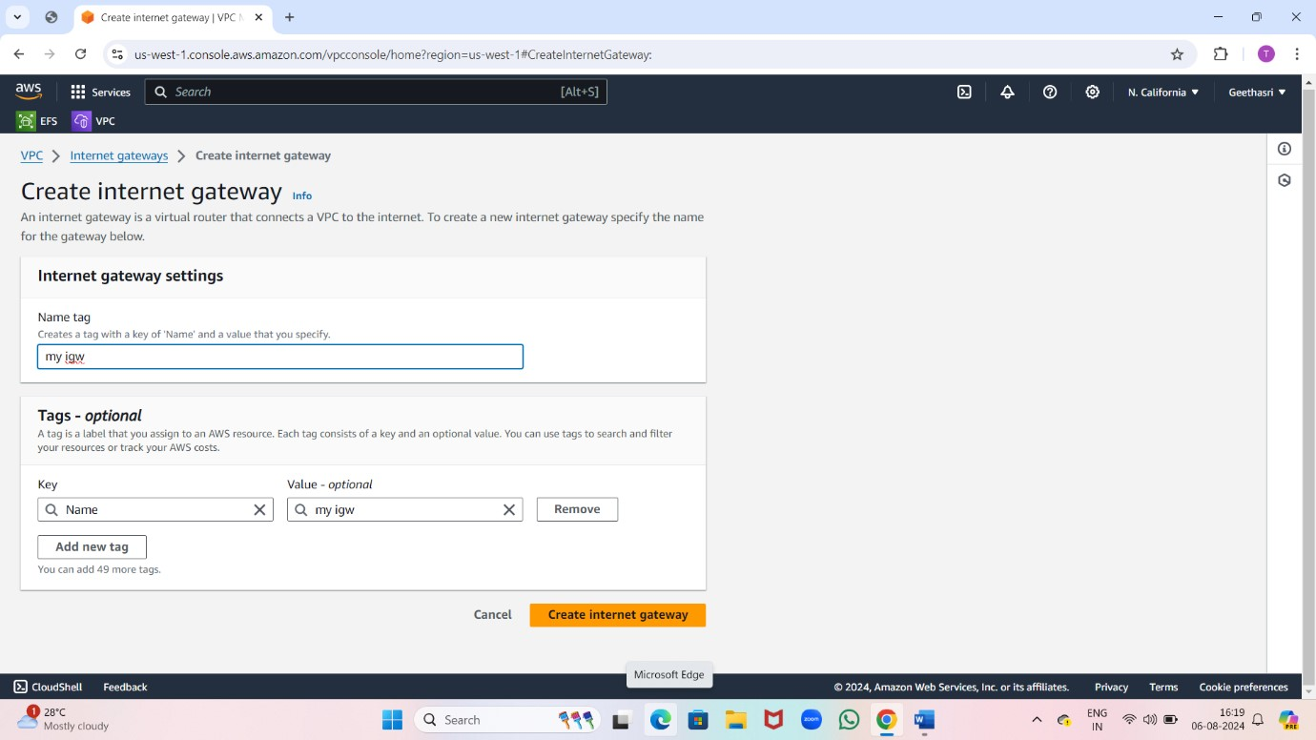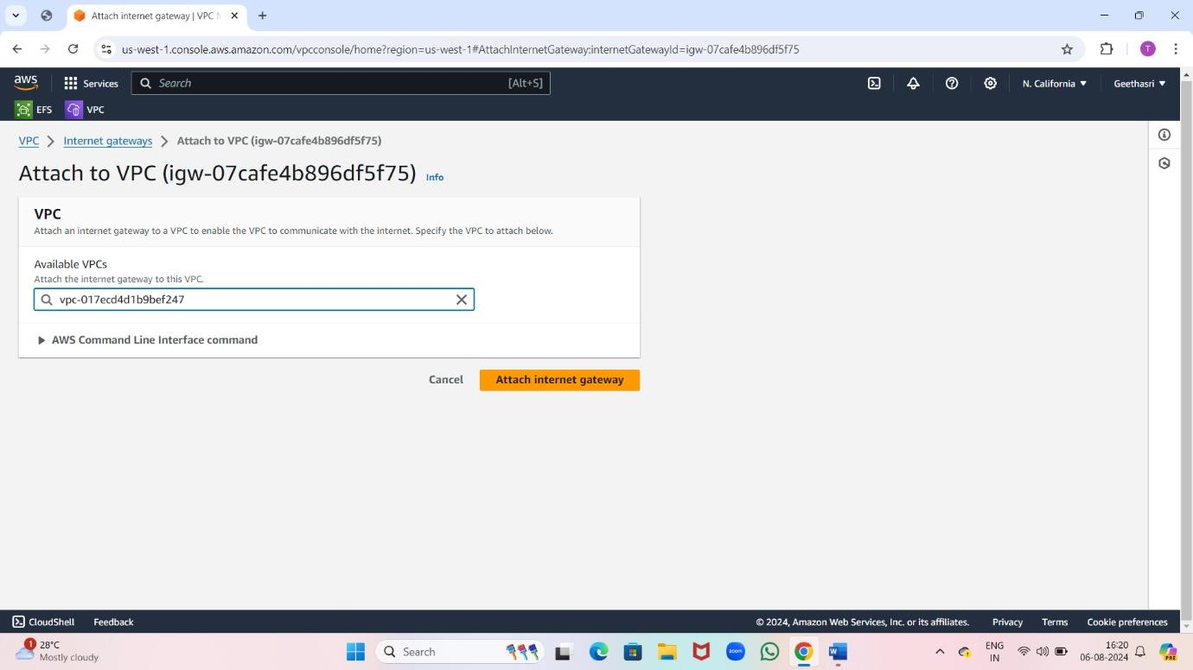

Now create a NAT gateway .

Click on “create NAT gateway”.

Attach VPC to NAT gateway.

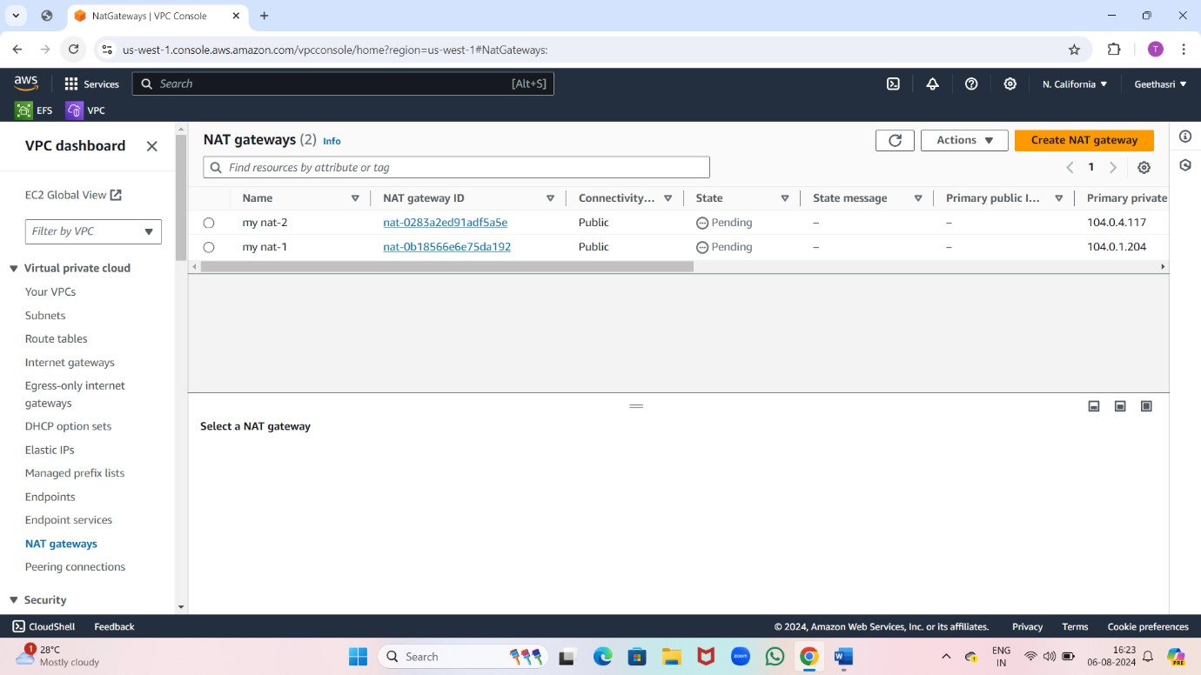

Now create a route table.

Click on “create route table”.

Associate subnets with route tables.

Click on “edit subnet”.

Select the route table.

Click on “ save changes”.

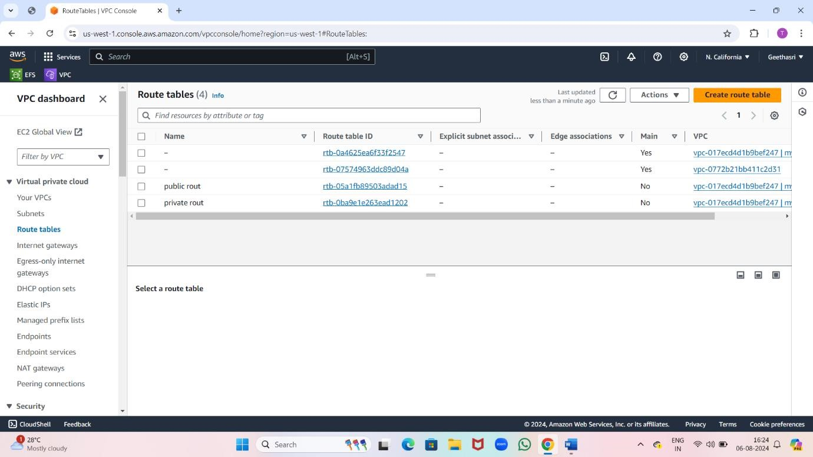

Now go to security group.

Click on “create security group”.

Enter the security group name and select the VPC where you want to create the security group.

Now click on “create security group”.

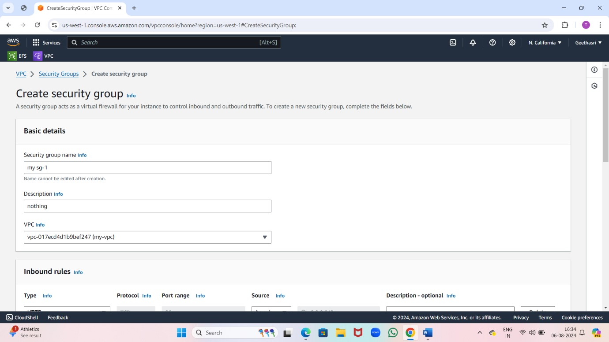

Now launch two templates.

Go to the EC2 dashboard.

Click on “instances” In the left- hand menu.

Select “ launch template” as the instance launch method.

Choose the launch template you want to use.

Select instance type.

Create key pair.

Choose security groups.

Select the subnet.

Click on “launch instances”.

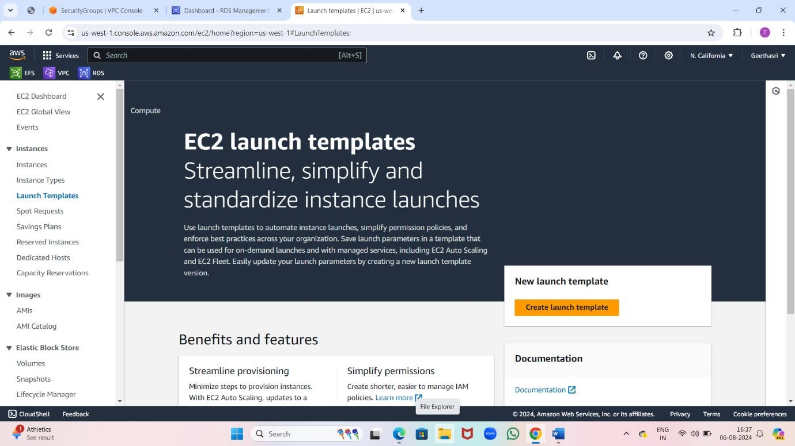

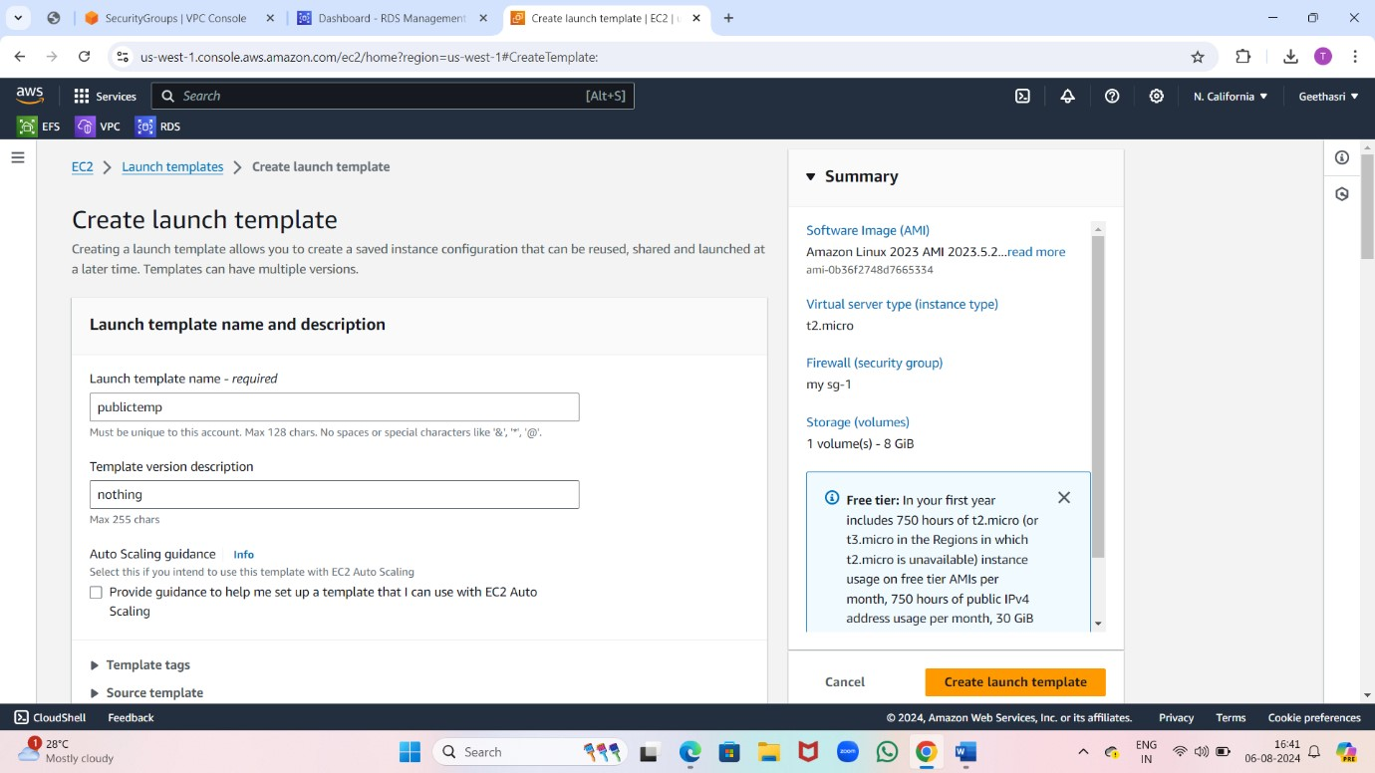

Now automatically EC2 instances will create.

Give names to created instances.

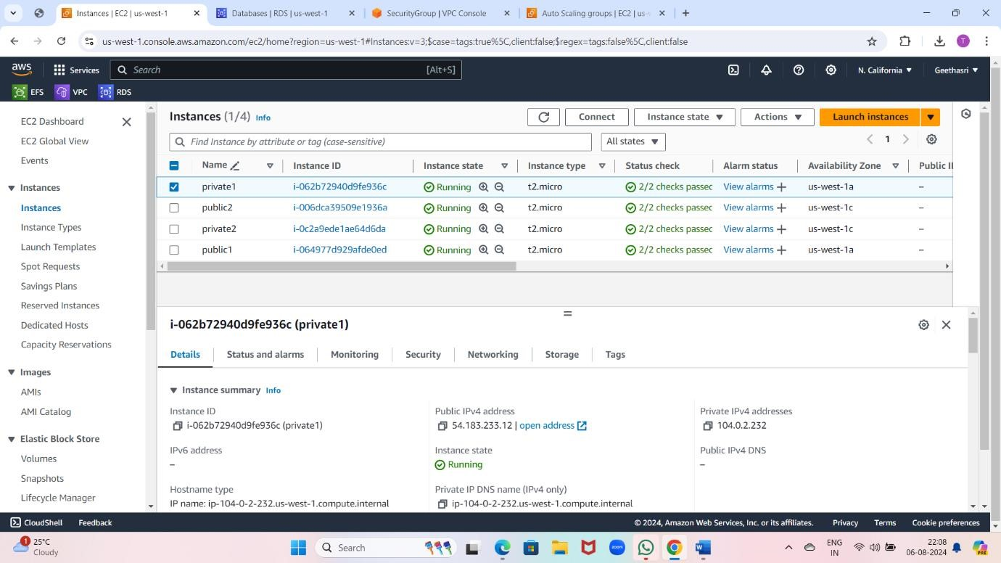

Connect public 1 instance to the web.

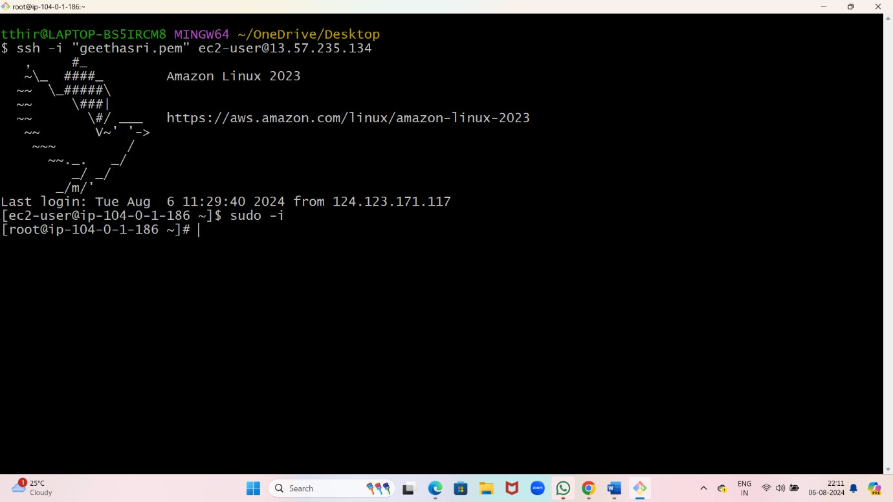

Install nginx in git bash.

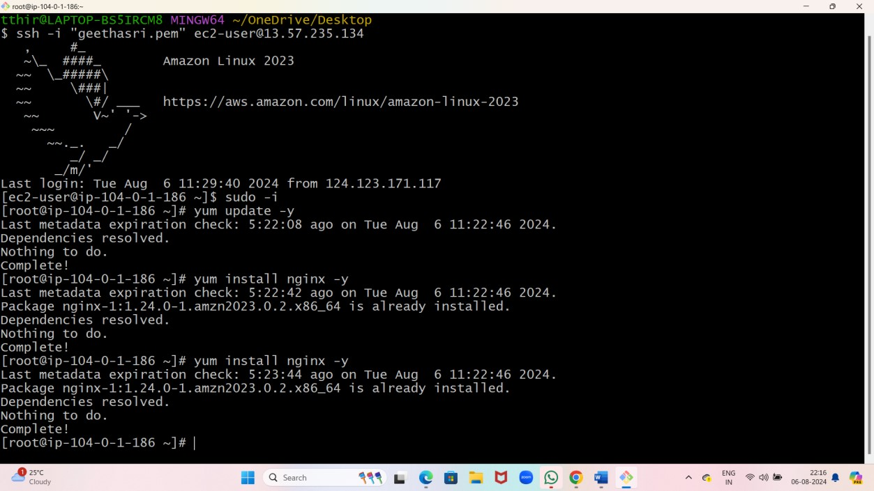

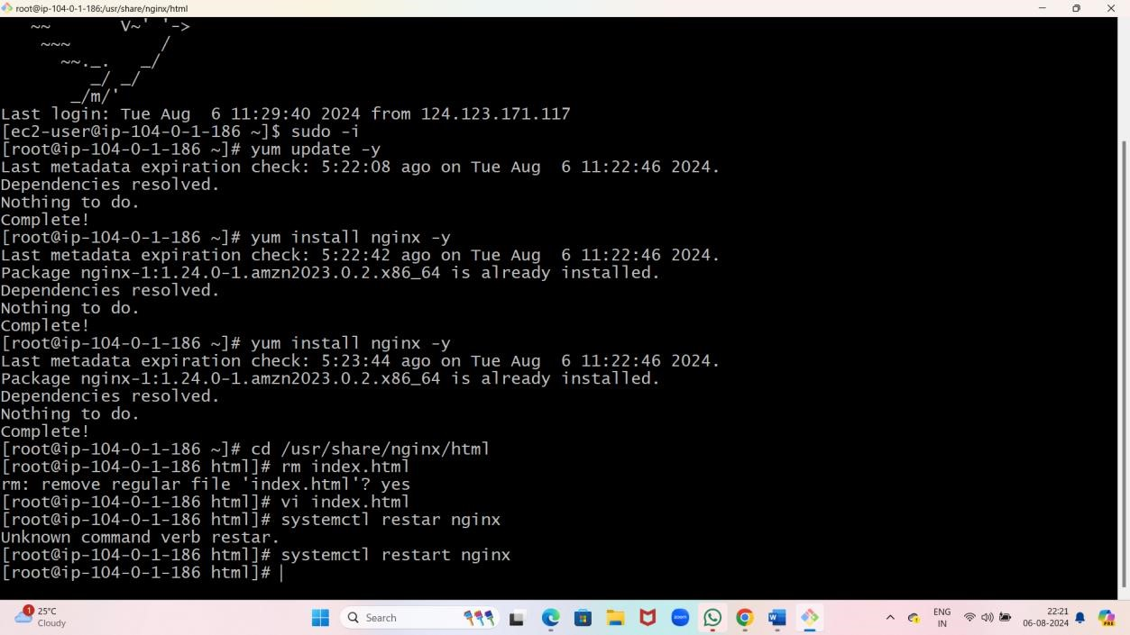

Copy public 1 Ip address and paste on google.

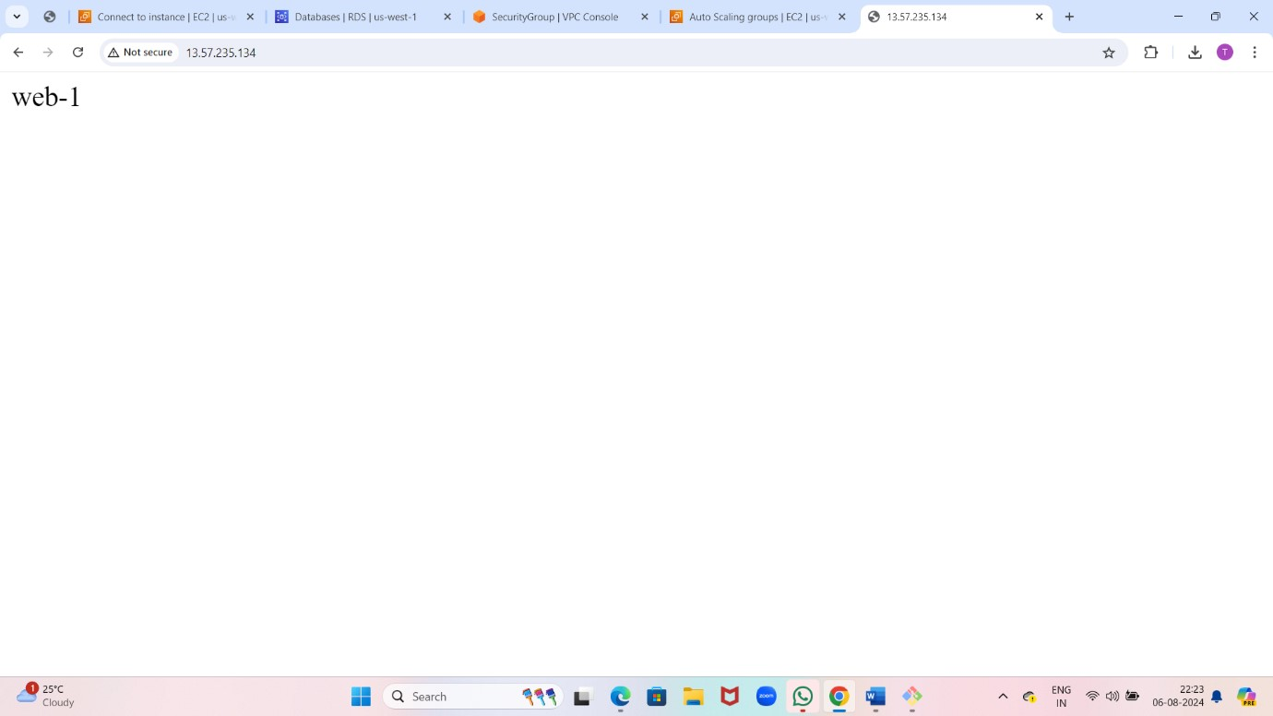

Now connect public 2 instance to web and install nginx.



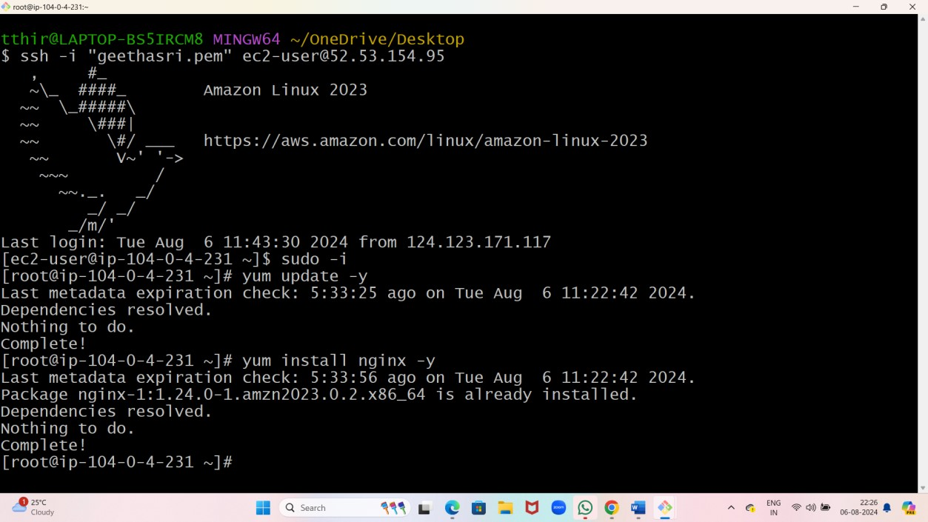

Copy public 2 Ip address and paste on google.

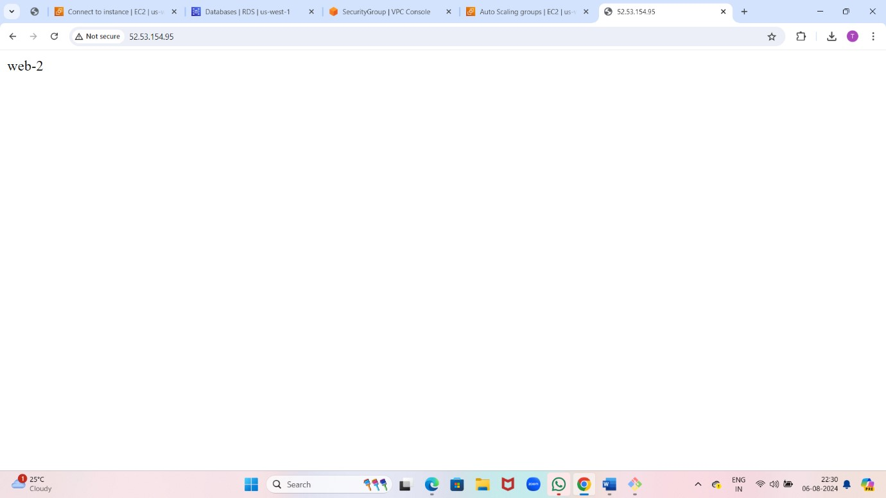

Now attach public 1 instance to private 1 instance.

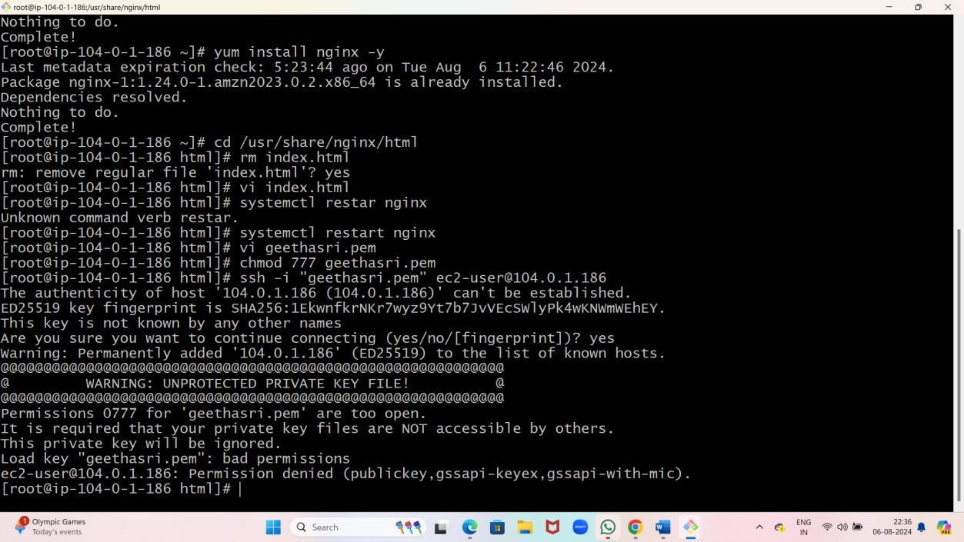

Now attach public 2 instance to private 2 instance.

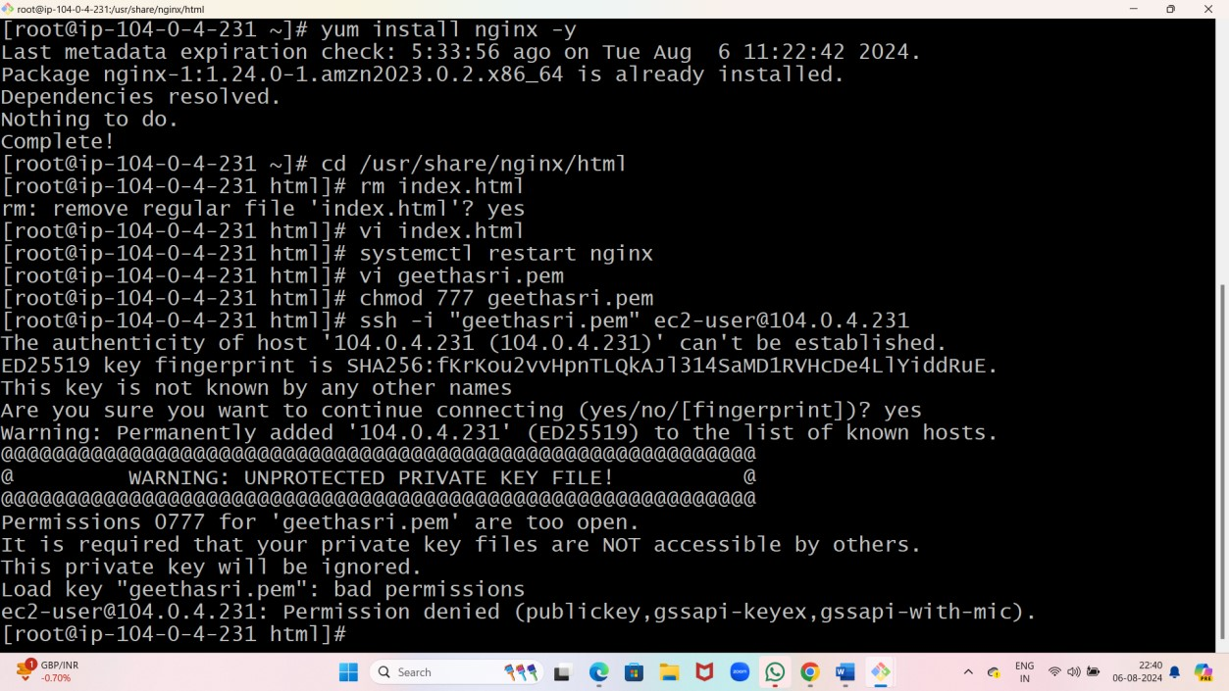

Now create database.

Go to the AWS management console and type RDS.

Click on RDS.

Click on “create database”.

Enter database name and master username and master password.

Click on “create database”.

